Build a Complete Medical Chatbot with LLMs, LangChain, Pinecone, Flask & AWS
- System Architecture
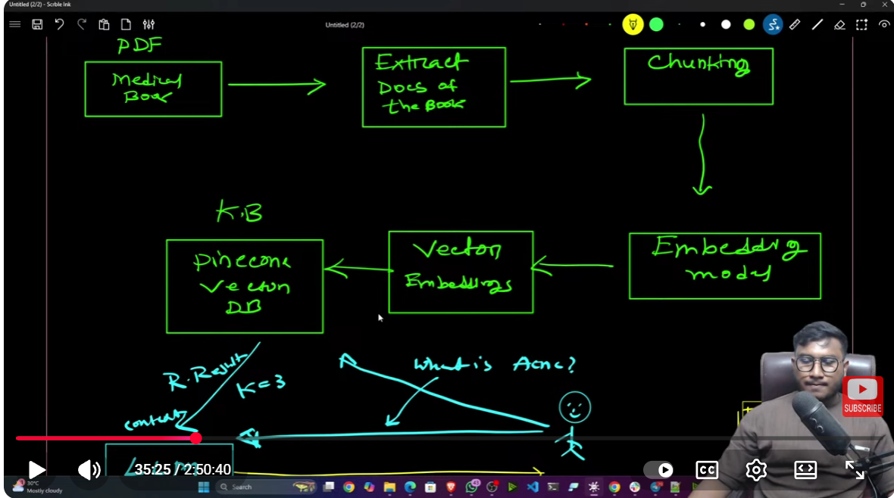

- Tech Stack
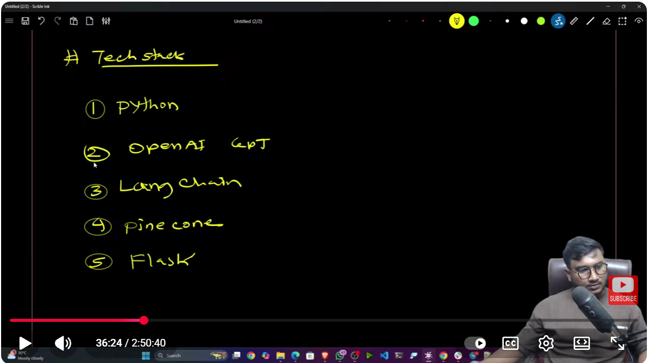
6. AWS – for deployment as CI/CD
- Vector Database
- LLM
- For orchestration workflow

- Deployment
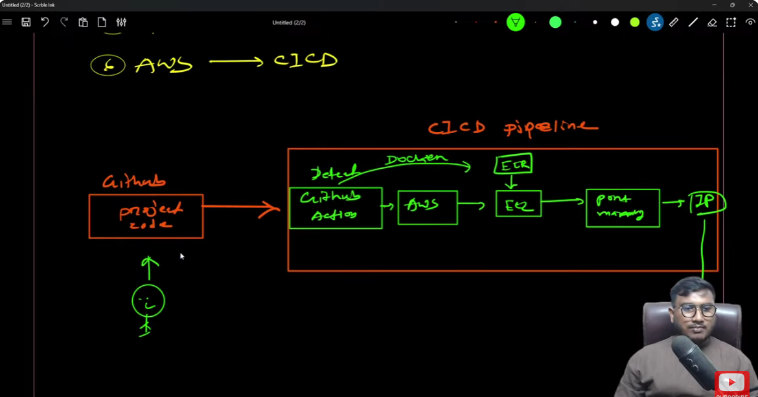

- Project Workflow
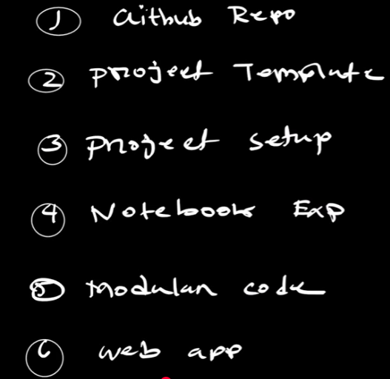
7. Deployment

- GitHub Repository
- Create new repository.
- Clone the repository to local:
Open the directory you desire in the file explorer > Open terminal > Will Git Bash pointing to the directory you are currently in in the file explorer > then run “git clone https://github.com/SweeSim25/Build-a-Complete-Medical-Chatbot-with-LLMs-LangChain-Pinecone-Flask-AWS.git”
- Build a Complete Medical Chatbot with LLMs .. folder is created in the file explorer.
- In the terminal again, run cd Bui (can use tab to auto fill up the cloned project folder name) and hit enter. You will be in the project folder.

